1. What is Generative AI? Key Concepts and Terminology
Generative AI refers to artificial intelligence systems that can create new content—such as text, images, audio, or code—that often appears indistinguishable from content created by humans. These systems learn patterns from existing data and use that knowledge to generate new, original outputs.

Gen AI Road Map
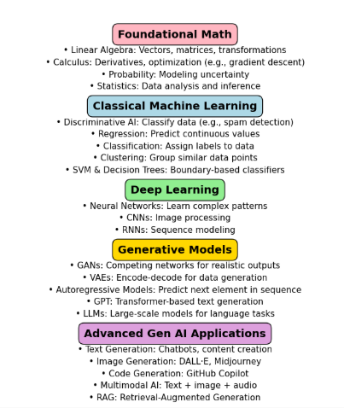

Foundational Math
- Linear Algebra
The study of vectors, matrices, and linear transformations. It's essential for representing and manipulating data in machine learning models.
- Calculus
Focuses on change and motion. In ML, it's used to optimize models through derivatives and gradients (e.g., gradient descent).
- Probability
Measures uncertainty and randomness. It helps models make predictions and decisions under uncertain conditions.
- Statistics
Involves collecting, analyzing, and interpreting data. It's crucial for understanding data distributions and evaluating model performance.
Classical Machine Learning
- Regression
A supervised learning technique used to predict continuous values (e.g., predicting house prices based on features).
- Classification
A supervised learning task where the goal is to assign input data to predefined categories (e.g., spam vs. not spam).
- Clustering
An unsupervised learning method that groups similar data points together without using labeled data (e.g., customer segmentation).
- Support Vector Machine (SVM)
A powerful classification algorithm that finds the optimal boundary (hyperplane) between different classes.
- Decision Trees
A model that splits data into branches based on feature values, leading to a decision outcome. Easy to interpret and visualize.
- Discriminative AI
A category of machine learning models that focus on distinguishing between different classes of data. These models learn the boundary between categories and are used for tasks like classification and regression.
Examples: Logistic Regression, SVM, Decision Trees, Neural Networks (for classification)

Deep Learning
- Neural Networks
Computational models inspired by the human brain. They consist of layers of interconnected nodes (neurons) that learn complex patterns.
- Convolutional Neural Networks (CNNs)
Specialized neural networks for processing grid-like data such as images. They use convolutional layers to detect spatial features.
- Recurrent Neural Networks (RNNs)
Designed for sequential data like time series or text. They maintain memory of previous inputs to inform current predictions.

Practical uses:
Neural Networks:
- Fraud Detection: Banks use neural networks to detect unusual patterns in transactions.
- Medical Diagnosis: Predicting diseases from patient data (e.g., diabetes, cancer).
- Customer Behavior Prediction: E-commerce platforms use them to recommend products.
Convolutional Neural Networks (CNNs)
- Image Classification: Identifying objects in photos (e.g., cats vs. dogs).
- Medical Imaging: Detecting tumors in X-rays or MRIs.
- Facial Recognition: Used in security systems and social media tagging.
- Autonomous Vehicles: Recognizing road signs, pedestrians, and other vehicles.

Recurrent Neural Networks (RNNs)
- Natural Language Processing (NLP): Language translation, sentiment analysis, and chatbots.
- Time Series Forecasting: Predicting stock prices, weather, or energy consumption.
- Speech Recognition: Converting spoken words into text (e.g., Siri, Google Assistant).
- Music Generation: Creating melodies based on learned patterns.

Generative Models
- Generative Adversarial Networks (GANs)
Consist of two networks—a generator and a discriminator—that compete. The generator creates data, and the discriminator evaluates it, leading to highly realistic outputs.
- Variational Autoencoders (VAEs)
Encode input data into a compressed representation and then decode it back, learning to generate new data similar to the input.
- Autoregressive Models
Predict the next element in a sequence based on previous elements. Used in language modeling and time series forecasting.
- GPT (Generative Pretrained Transformer)
A type of autoregressive model based on the transformer architecture. It generates coherent and context-aware text by predicting the next token in a sequence.

- LLMs (Large Language Models)
Advanced generative models trained on massive text datasets. Built on transformer architecture, they can perform a wide range of tasks such as answering questions, summarizing, translating, and generating text.
Examples: GPT-3, GPT-4, PaLM, LLaMA, Claude

1. Self-Attention Mechanism
What it is:
A technique that allows a model to focus on different parts of a sentence when processing each word.
Simple analogy:
Imagine reading a sentence like:
"The cat sat on the mat because it was tired."
To understand what "it" refers to, your brain looks back at "cat."
Self-attention does the same — it helps the model decide which words are important to look at when understanding or generating text.
Why it matters in LLMs:
It enables models to understand context and relationships between words, even if they’re far apart in a sentence.

2. Embedding
What it is:
A way to convert words or sentences into numbers (vectors) that capture their meaning.
Simple analogy:
Think of embedding as placing words on a map. Words with similar meanings (like "king" and "queen") are placed close together.
Why it matters in LLMs:
Embeddings allow models to compare meanings, find similarities, and understand context — not just match exact words.

3. Transformer Model
What it is:
A type of neural network architecture that uses self-attention to process and generate text.
Simple analogy:
Imagine a smart assistant that reads a paragraph and instantly knows which parts are important, how they relate, and what to say next — that’s what a transformer does.
Why it matters in LLMs:
Transformers are the backbone of modern LLMs. They allow models to handle long-range dependencies, generate coherent text, and scale efficiently.

4. Neural Network
What it is:
A system of interconnected "neurons" (mathematical functions) that learn patterns from data.
Simple analogy:
Like a brain made of math — it learns by adjusting connections based on examples.
Why it matters in LLMs:
Neural networks are the foundation of all deep learning models, including transformers. They learn how to predict the next word, answer questions, and more.

RLHF 2 O/P

Advanced Generative AI Applications
- Text Generation
Creating human-like text for chatbots, content writing, summarization, translation, and more.
Example: ChatGPT
- Image Generation
Producing realistic or artistic images from text prompts using generative models.
Example: DALL·E, Midjourney
- Code Generation
Automatically writing or completing code using AI trained on programming languages.
Example: GitHub Copilot
- Multimodal AI
Combining multiple data types (e.g., text, images, audio) to understand and generate richer content.
Example: GPT-4 with vision, Gemini, CLIP

- RAG (Retrieval-Augmented Generation)
Enhancing generative models by retrieving relevant external information before generating a response.
Example: Enterprise search assistants, domain-specific chatbots.

- GPT-4 is ideal for tasks needing high precision and deep reasoning, like legal analysis or complex problem-solving.
- GPT-4o is optimized for speed, cost-efficiency, and multimodal interaction, making it perfect for real-time applications, voice assistants, and tasks involving images or audio.

Creation of LLM:

Creating a Large Language Model (LLM) like GPT-3 involves a more complex and resource-intensive process than typical machine learning projects. While understanding the basic data science workflow is essential, developing an LLM requires additional steps, specialized knowledge, and significant computational resources. Here’s an overview of the process and additional considerations:

Steps to Create a Large Language Model (LLM)

- Understanding the Problem Statement:
  - Objective: Define the goals and scope of the LLM. Determine what tasks the model should perform, such as text generation, translation, summarization, etc.
  - Example: Developing a model that can generate human-like text based on given prompts.

- Data Collection:
  - Objective: Gather a massive and diverse dataset to train the LLM. This typically involves collecting text data from various sources such as books, articles, websites, and social media.
  - Example: Collecting billions of words from diverse sources to ensure the model learns a wide range of language patterns and contexts.

- Data Cleaning and Preprocessing:
  - Objective: Clean and preprocess the data to ensure quality and consistency. This involves removing duplicates, filtering out inappropriate content, and tokenizing the text.
  - Example: Removing HTML tags, normalizing text, and converting it into a format suitable for training (e.g., tokenization).
- Data Exploration and Analysis:
  - Objective: Analyze the data to understand its characteristics and ensure it is representative of the language patterns you want the model to learn.
  - Example: Analyzing the distribution of word frequencies, sentence lengths, and topics covered in the dataset.
- Model Architecture Design:
  - Objective: Design the architecture of the LLM. This involves selecting the type of neural network (e.g., Transformer), the number of layers, the size of the model, and other hyperparameters.
  - Example: Designing a Transformer-based model with 175 billion parameters, similar to GPT-3.
- Model Training:
  - Objective: Train the LLM on the collected data. This requires significant computational resources, such as powerful GPUs or TPUs, and can take weeks or months.
  - Example: Using distributed training across multiple GPUs/TPUs to handle the large-scale computations required for training the model.
- Model Evaluation:
  - Objective: Evaluate the model’s performance using various metrics and benchmarks. This involves testing the model on tasks such as language understanding, text generation, and more.
  - Example: Evaluating the model’s performance on standard NLP benchmarks like GLUE, SuperGLUE, and others.
- Fine-Tuning:
  - Objective: Fine-tune the model on specific tasks or domains to improve its performance. This involves additional training on smaller, task-specific datasets.
  - Example: Fine-tuning the model on a dataset of customer service interactions to improve its ability to generate helpful responses.
- Deployment and Optimization:
  - Objective: Deploy the model to a production environment and optimize it for performance and scalability. This involves setting up infrastructure, monitoring, and continuous improvement.
  - Example: Deploying the model as an API that can handle high volumes of requests and optimizing it for low latency and high throughput.

Additional Considerations
- Computational Resources: Training an LLM requires significant computational power, often involving clusters of GPUs or TPUs.
- Data Privacy and Ethics: Ensuring that the data used for training respects privacy and ethical guidelines.
- Scalability: Designing the system to handle large-scale deployment and usage.
- Maintenance: Continuously monitoring and updating the model to ensure it remains accurate and relevant.
Conclusion
While understanding the basic data science workflow is crucial, creating an LLM involves additional complexities and resources. It requires expertise in deep learning, access to large-scale computational resources, and careful consideration of ethical and practical issues. By following these steps and addressing these considerations, it is possible to develop and deploy a large language model.

How LLMs Are Created
1. Data Collection
LLMs are trained on massive datasets that include:
- Public code repositories (like GitHub)
- Text from books, websites, documentation
- Forums like Stack Overflow
This helps the model learn patterns in language and code.
2. Tokenization
Text and code are broken down into smaller units called tokens (words, symbols, or parts of words). This makes it easier for the model to process and understand structure.
3. Model Architecture
Most LLMs use a Transformer architecture, which is designed to:
- Understand context
- Handle long-range dependencies in text/code
- Generate coherent and relevant output
4. Training
The model is trained using unsupervised learning:
- It tries to predict the next token in a sequence.
- It adjusts its internal parameters (weights) based on how close its prediction was to the actual token.
- This process is repeated billions of times across the dataset.
5. Fine-Tuning
After initial training, the model may be fine-tuned on specific tasks:
- Code generation
- Bug fixing
- Documentation writing
This helps specialize the model for tools like GitHub Copilot.
6. Deployment
Once trained, the model is:
- Hosted on powerful servers
- Integrated into tools like Copilot via APIs
- Continuously monitored and updated

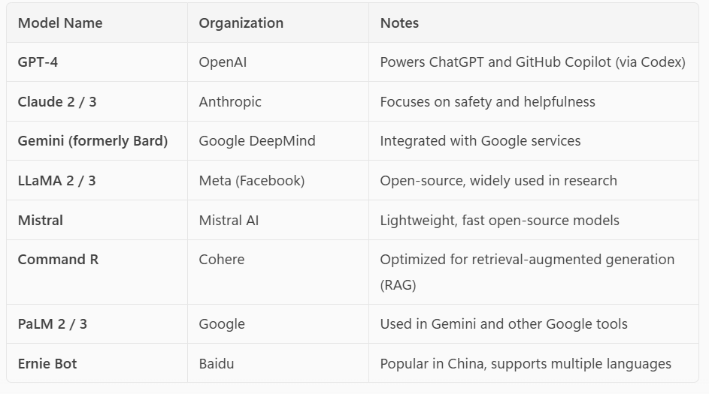
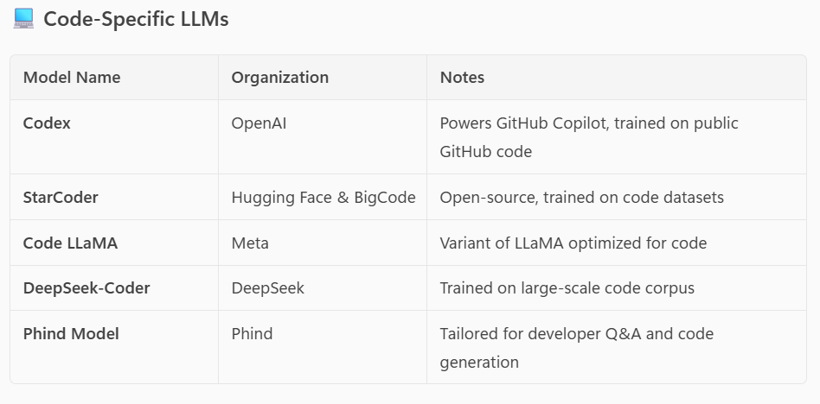

🔑 Key Differences Between LLMs
1. Training Data
- GPT-4 (OpenAI): Trained on a mix of internet text, books, code, and more. Very broad and diverse.
- Claude (Anthropic): Focuses on curated, high-quality data with safety in mind.
- Gemini (Google): Uses Google-scale data, including search and YouTube transcripts.
- LLaMA (Meta): Trained on open datasets like Common Crawl, Wikipedia, etc.
- Codex (OpenAI): Specifically trained on public GitHub code for programming tasks.
2. Model Size & Architecture
- GPT-4: Very large, multi-modal (can handle text and images).
- Claude 3: Optimized for long context windows (can handle large documents).
- LLaMA 3: Comes in various sizes (7B, 13B, etc.) for different use cases.
- Mistral: Smaller, faster models optimized for edge devices and open-source use.
3. Specialization
- Codex, StarCoder, Code LLaMA: Specialized for programming and code generation.
- Command R (Cohere): Optimized for retrieval-augmented generation (RAG).
- Jais, Yi: Focused on regional languages like Arabic and Chinese.
4. Capabilities
- GPT-4, Claude 3, Gemini: Strong in reasoning, summarization, and multi-turn conversations.
- Codex, StarCoder: Excellent at generating and understanding code.
- Mistral, LLaMA: Good for research and open-source experimentation.
5. Access & Licensing
- GPT-4, Claude, Gemini: Proprietary, accessed via APIs.
- LLaMA, Mistral, StarCoder: Open-source, can be run locally.
- Codex: Proprietary, used in GitHub Copilot.
6. Safety & Alignment
- Anthropic’s Claude: Designed with safety and ethical alignment as a core goal.
- OpenAI’s GPT-4: Includes safety mechanisms but is more general-purpose.
- Google’s Gemini: Includes safety filters and integrates with Google’s ecosystem.

Selecting the Right Foundation Model for Your Generative AI Application
Choosing the right foundation model is a critical step in building a successful generative AI solution. It determines how well your application performs, scales, and meets user expectations. A structured approach can help guide your decision-making process.

1. Can AI Solve My Use Case?
Before selecting a model, ask: Can AI effectively address my use case?
With thousands of models available, the challenge is identifying one that fits your needs. Begin by exploring model catalogs such as:
- Hugging Face – Offers a wide range of open-source models across domains.
- GitHub – Hosts models from various developers and platforms.
- Other AI platforms – Provide curated catalogs with deployment tools.
Model Types to Consider:
- Large Language Models (LLMs) like GPT-4, Llama3 70B, and Mistral Large are ideal for complex tasks requiring deep reasoning and rich context understanding.
- Small Language Models (SLMs) such as Phi3 and Llama3 8B are lightweight, cost-effective, and suitable for simpler tasks or edge deployments.
Modality and Task Focus:

Text-based models (e.g., GPT-4) for chat, summarization, and content generation.
Reasoning models (e.g., DeepSeek-R1) for logic-heavy tasks like coding or strategy.
Multi-modal models (e.g., GPT-4o, Phi3-vision) for handling text, images, and audio.
Image generation models (e.g., DALL·E 3, Stability AI, Midjourney, Gemini NanoBanana) for visual content creation.
Embedding models (e.g., Ada, Cohere, SentenceTransformers (SBERT), Mistral-Embed) for semantic search and recommendation systems.
Function-calling models for structured data tasks like API automation or database queries.
(GPT-4 Turbo / GPT-4o / GPT-5 – Native support for function calling and tool use,
LangChain + OpenAI – Framework for building agentic systems with function calling.)

Specialized Models:
Regional models (e.g., Core42 JAIS for Arabic, Mistral Large for European languages).
Domain-specific models (e.g., Nixtla TimeGEN-1 for time-series forecasting).

Open vs. Proprietary Models:

Proprietary models offer high performance, enterprise-grade support, and security.
Open-source models provide flexibility, customization, and cost-efficiency.
Open-Source Models
These models are publicly available, and their architecture, weights, and training data (or methodology) are often shared with the community.
Key Benefits:
- Flexibility: You can modify, fine-tune, and deploy them as needed.
- Cost-Efficiency: No licensing fees; ideal for budget-conscious projects.
- Transparency: You can inspect how the model works and what data it was trained on.
- Community Support: Active development and contributions from researchers and developers.
Examples:
- LLaMA 2 / LLaMA 3 – Meta
- Mistral 7B / Mixtral – Mistral AI
- Falcon – TII
- BLOOM – BigScience
- BERT / RoBERTa / DistilBERT – Hugging Face

Proprietary Models
These are developed and owned by companies. Their internal workings are not publicly disclosed, and access is typically provided via paid APIs or platforms.
Key Benefits:
- High Performance: Often outperform open models in benchmarks.
- Enterprise-Grade Support: SLAs, customer support, and integration tools.
- Security & Compliance: Built-in features for data privacy and regulatory needs.
- Optimized Infrastructure: Hosted on scalable, reliable platforms.
Examples:
- GPT-4 / GPT-4o – OpenAI
- Claude – Anthropic
- Gemini – Google DeepMind
- Command R+ – Cohere
- Jurassic-2 – AI21 Labs

Choosing Between Them

Criteria | Open-Source | Proprietary
Cost | Free or low-cost | Paid (API usage)
Customization | Full control | Limited or none
Performance | Good, improving | Often best-in-class
Transparency | High | Low
Deployment | Local or cloud | Cloud/API only
Support | Community-driven | Enterprise-grade

2. How Do I Select the Best Model for My Use Case?
Once you know AI can help, the next step is choosing the most suitable model. Consider these filtering criteria:
Key Selection Criteria:
- Task Type – What kind of input/output does your app require? Text, audio, video, or multi-modal?
- Precision – Do you need a general-purpose base model or a fine-tuned model for specific tasks?
- Openness – Do you want to fine-tune or customize the model?
- Deployment – Will the model run locally, on the cloud, or via serverless endpoints?
Precision Matters:
- Base models are versatile but may lack domain-specific accuracy.
- Fine-tuned models are trained on specialized datasets for better relevance and precision.
Performance Evaluation:
Use benchmarks to compare models:
- Accuracy – How well does the output match expected results?
- Coherence – Does the output flow naturally?
- Fluency – Is the language grammatically correct?
- Groundedness – Is the output aligned with input data?
- Semantic Similarity – How close is the output to the intended meaning?
- Quality Index – Aggregate score comparing overall performance.
- Cost – Token-based pricing to balance quality and budget.
Evaluation Methods:
- Manual evaluation – Quick, subjective review of model responses.
- Automated evaluation – Objective metrics like precision, recall, and F1 score using ground truth data.

3. Can I Scale for Real-World Workloads?
Once your model works well in testing, you need to prepare it for real-world use. This involves:

Deployment Strategy
Choose where and how your model will run — locally, on cloud servers, or using serverless endpoints — to balance performance and cost.

Monitoring & Optimization
Continuously track how the model performs (speed, accuracy, errors) and make improvements based on user feedback and system metrics.

Prompt Management
Refine and structure your prompts to get more accurate, relevant, and consistent responses from the model.

Model Lifecycle Management
Regularly update your model, data, and application code to keep everything current and aligned with evolving needs. This is part of a broader process called GenAIOps (Generative AI Operations).
Responsible AI principles are a set of guidelines and values that ensure artificial intelligence systems are developed and used in ways that are ethical, fair, transparent, and beneficial to society. These principles are adopted by many organizations, including Microsoft, Google, and others, to guide the responsible development and deployment of AI technologies.
Core Responsible AI Principles
Here are the most widely recognized principles:
1. Fairness
- AI systems should treat all people fairly and avoid bias.
- Example: Avoiding discrimination in hiring tools or loan approvals.
2. Reliability & Safety
- AI should perform reliably and safely under expected conditions.
- Systems must be tested thoroughly to avoid harmful failures.
3. Privacy & Security
- AI must protect user data and ensure privacy.
- Data should be collected and used responsibly, with strong security measures.
4. Inclusiveness
- AI should empower everyone and be accessible to people with diverse needs.
- Example: Supporting multiple languages, accessibility features for people with disabilities.
5. Transparency
- People should understand how AI systems work and how decisions are made.
- This includes explainability and clear documentation.
6. Accountability
- Developers and organizations must be accountable for their AI systems.
- There should be mechanisms for redress if harm is caused.
